

***Name: Nguyen Manh Dung***

***Student ID: 104181789***

***Group name: The Shoesroom***

**COS10026**

**COMPUTING TECHNOLOGY**

**INQUIRY PROJECT**

**Assignment 2**

**REPORT**

**Assignment Part 2:**

**Individual report**

A Report Submitted in Partial Fulfillment of the Requirements for Assignment 2 Project

Submitted to: Swinburne University IT Department, Ms Nguyen Phuong Anh (Unit Convenor of COS10026.2)

By: Nguyen Manh Dung

Id:104181789

Date of Submission: 10/4/2023

1. Introduction
2. Objective of the report

In this assignment 2 (Server-Side Programming), we extend our previous project in Assignment 1 by including payment details, sign in-up, and register parts.

1. Table of contents

* Website’s new features:
  + The website's primary features, including screenshots.
  + Technical information on the creation of the website.
  + Emphasize the distinctive or important characteristics of the website.
* My contribution
* Reflection and discussion
* Conclusion
* References

1. The website
2. Our website’s new features

In Part 1 of the project, we established a website using HTML and CSS. Now, in Part 2, our group will extend the functionality of the website using server-side scripting. We use PHP to create dynamic web page content and connect to a MySQL database server.

-The function of the index, products are almost unchanged compared to Assignment 1



-We changed the page about to be enhancement page:

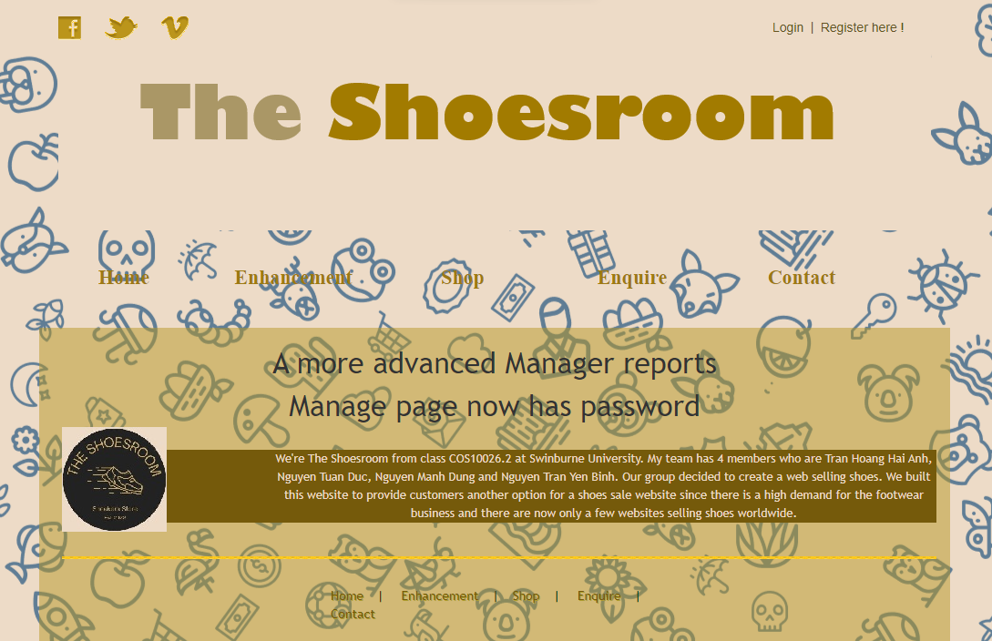This is the new enhancement page:

* We have extended enquire page (enquire.php) to have the personal payment details parts:

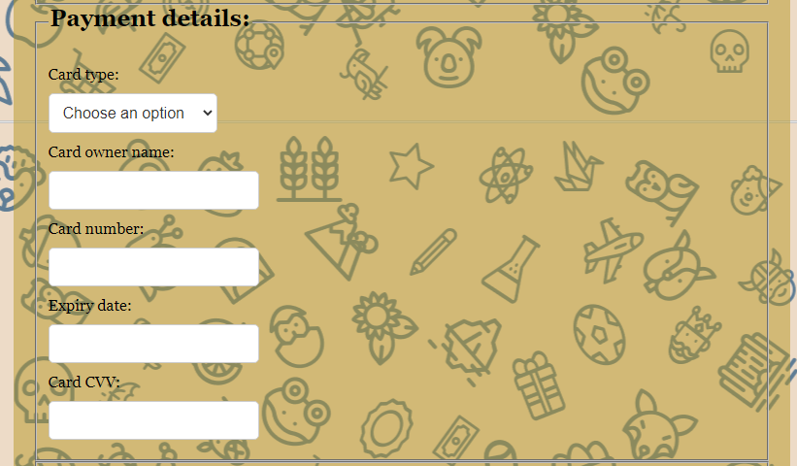 This is one of our new features.

* In this part the user must enter his/her information correctly, If not, it will navigate us to (fix_order.php), which is the page that let us fix our wrong Card requirements or information.

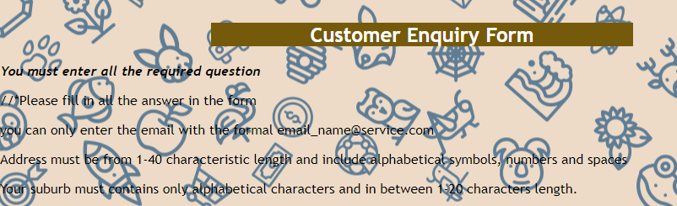You will see this information if you did not follow the requirements

And if you type the correct information requirement, it will navigate to receipt.php page 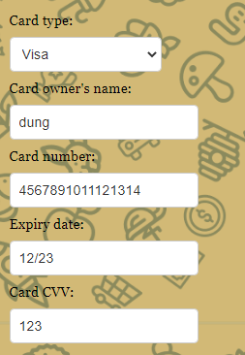 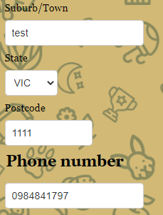

Assume that above image is the correct details:

* The website will respond with a table like this (receipt.php), including all your entered information:

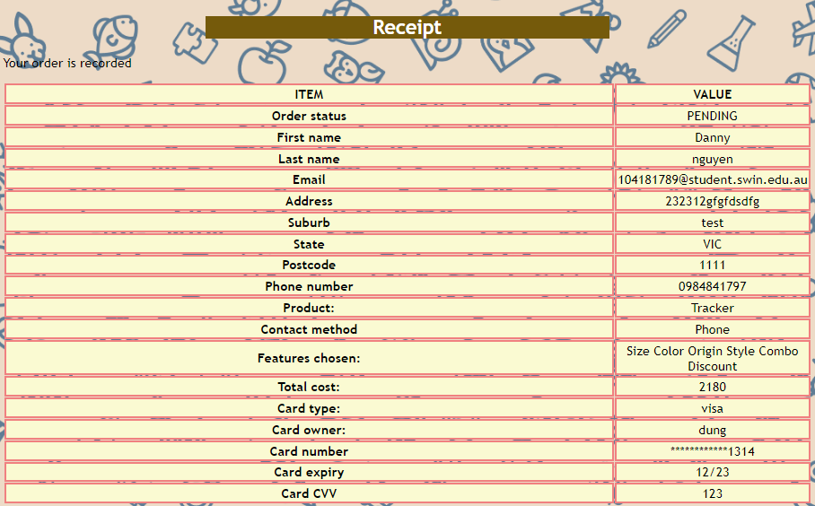 All the entered information has included in this table. And they will be inserted into database:

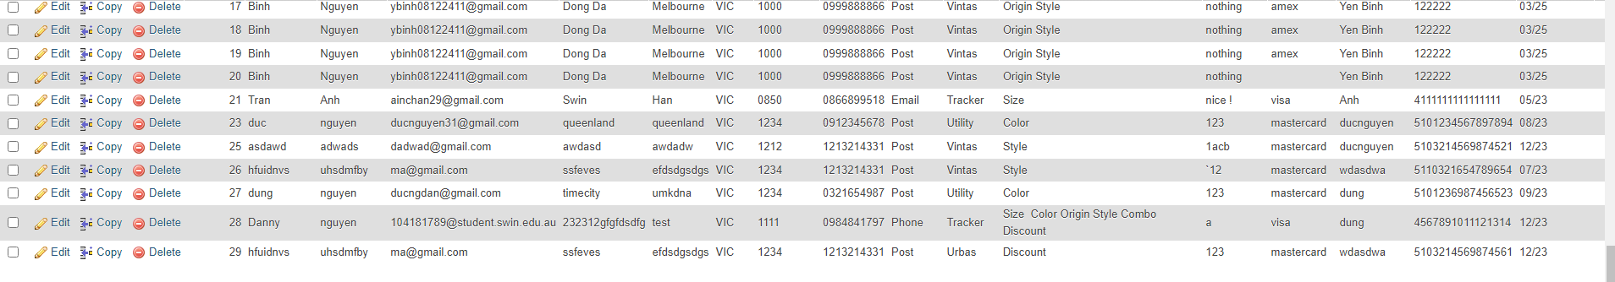

* Our new page on your website called manage.php is designed to provide users with a convenient way to query orders, view the results in an HTML table, and update the status of orders. This is a great feature to have, as it can help users keep track of their orders and ensure that everything is progressing as it should.

To search for an order on the manage.php page, the user can enter their desired in the appropriate search field. For example, they might enter the order number, the name of the customer who placed the order, or the date that the order was placed. Alternatively, they can leave the search field blank if they want to show all orders.

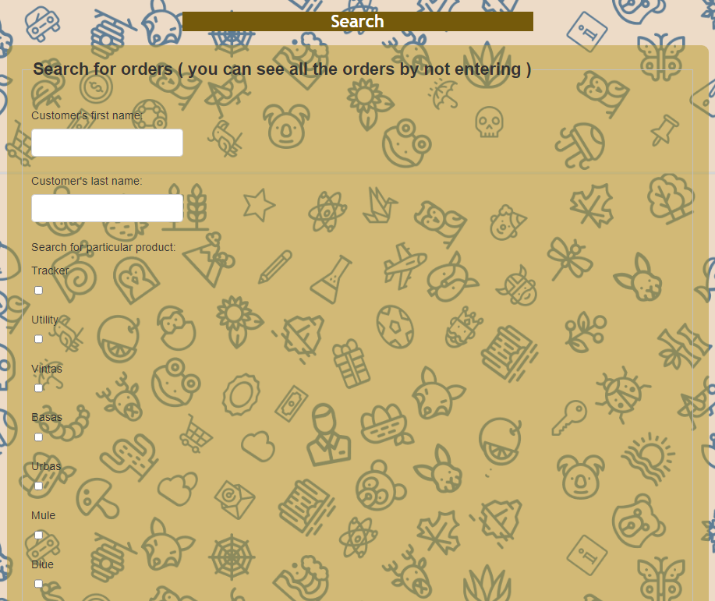

Once the user has entered their desired customization or left the search field blank, they can click on the "Find" button to initiate the search.

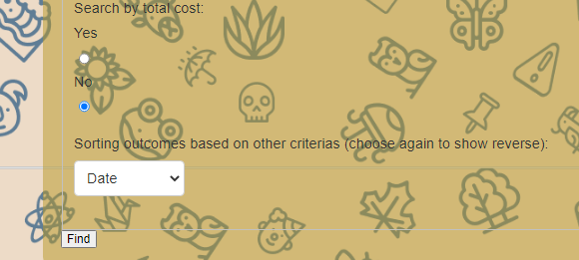

The system will then search through the database of orders and retrieve any orders that match the user's search criteria.If the search returns any results, they will be displayed in an HTML table on the manage.php page.

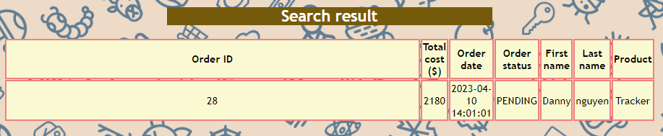

The table will include information such as the order number, the name of the customer who placed the order, the date that the order was placed, and the status of the order.

* If the user wants to update the status of an order, they can do so directly from the HTML table. They can click on the "Update" button next to the order they want to modify, then select the new status from the dropdown menu.

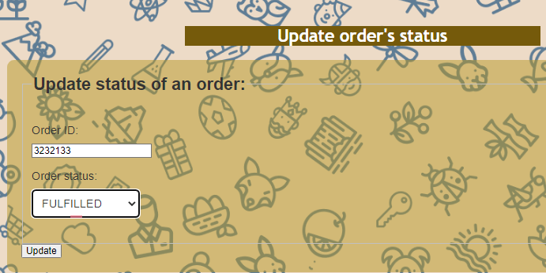

* User can also delete Pending order: 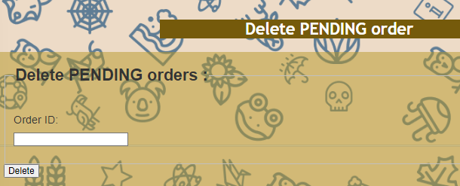
* Or even modify the advane resule (as part of the enhancement): 
* We also extend login.php to make user can create a account also register to make a new one. The user data will be sent to the database:

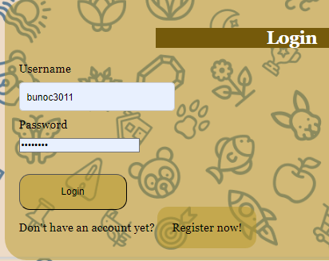 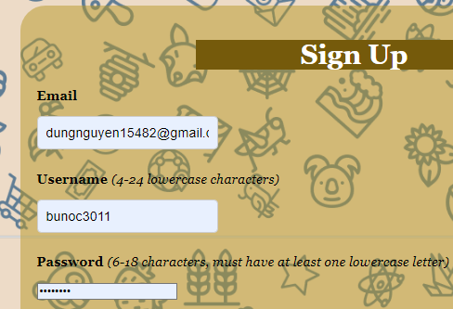We can see the data that I type

The data has been updated into database

1. My contribution

* Me and Tran Hoang Hai Anh are in charge of the payment.php and process_order.php which include fix_order and receipt page. And I am also made the login and log out page.

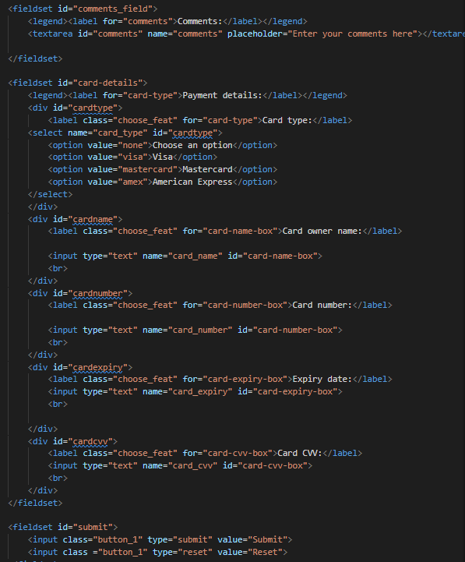 As part of our ongoing efforts to improve the user experience on our website, we recently extended the payment page to allow users to enter their credit card information and make online payments. This is a significant enhancement that can make the checkout process smoother and more convenient for our customers.

* We create variables that require the input to fit with the requirements, moreover to extract the data from enquire page to process.when the pattern is not in the proper format, a message will be displayed. 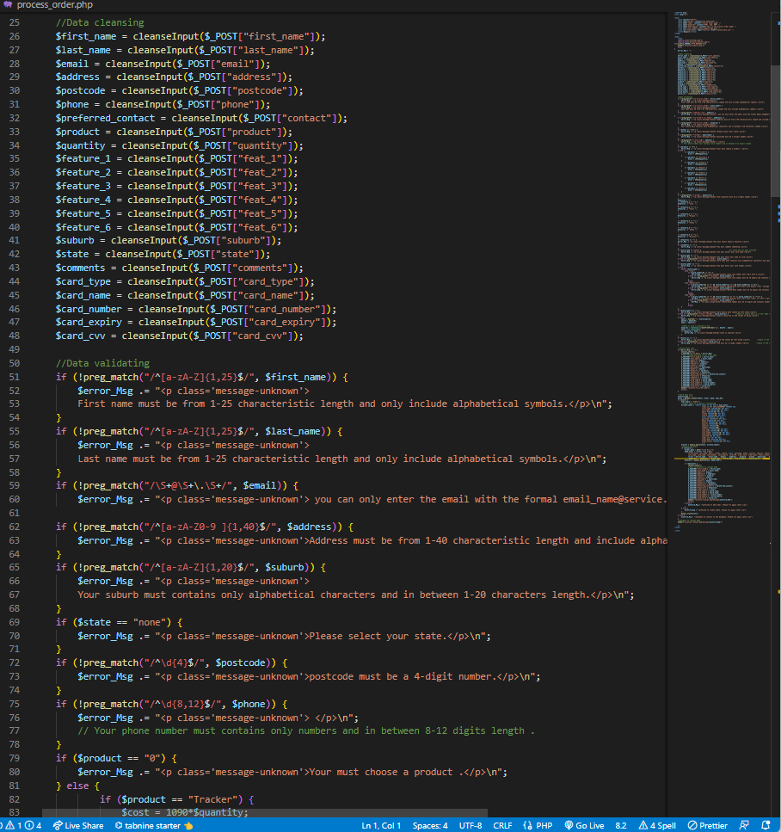 When the pattern is not in the proper format, a message will be displayed.
* To calculate the total cost of product, we code to match with the quantity so that the total cost will equal to product*quantity. 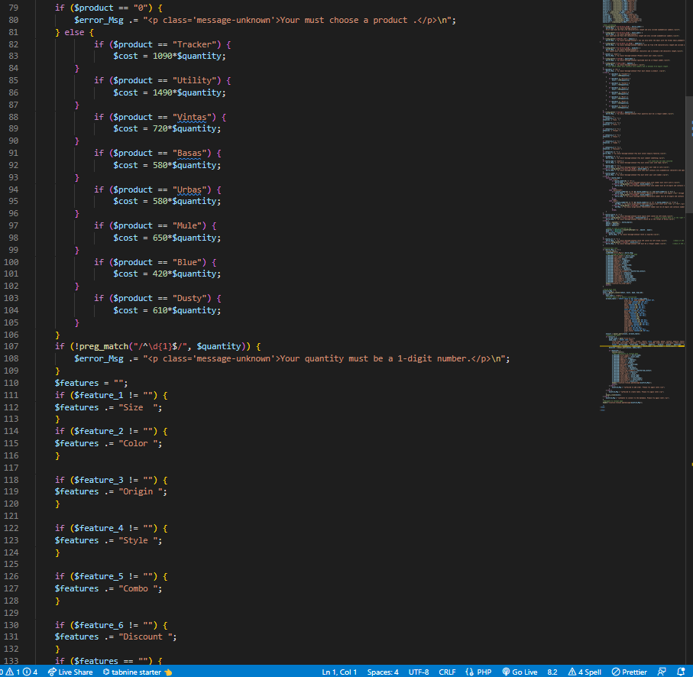 The total cost that the user must pay is determined by multiplying the price by the amount.
* In terms of the payment details, most of the requirements is correct due to the “if-elseif” code. 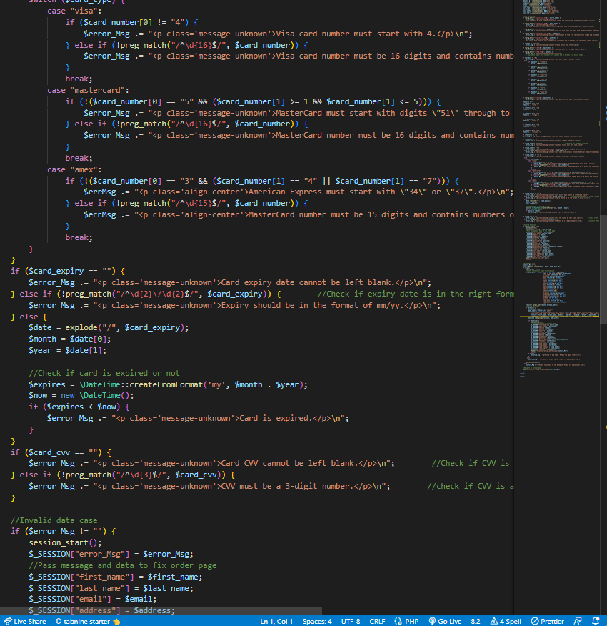
* One of the requirements when we submit the card information, the page receipt.php must encrypt the first 12 digits. So I put a requirement for that variables: 
* Sign up (signup.php): On this page, there is a form where users can register for a new account and input their email, username, and password. Here is some of algorithm that we made to check the login.php page: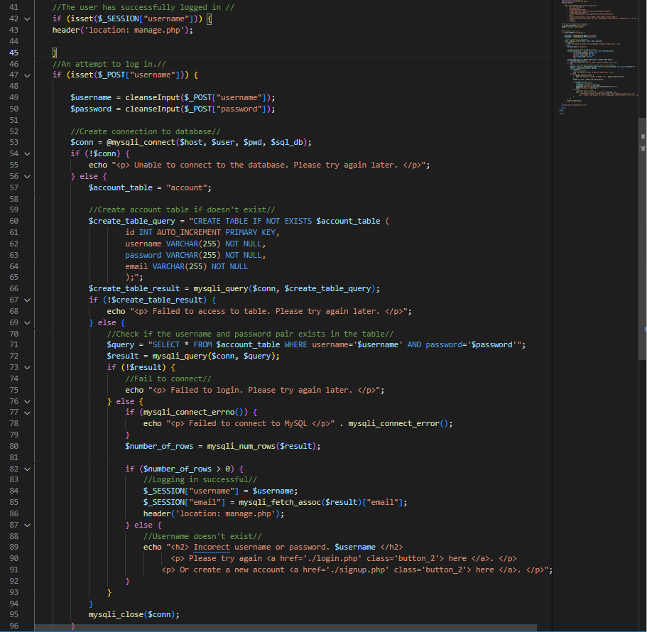

If there isn't already a database ("account" table), one will be created. 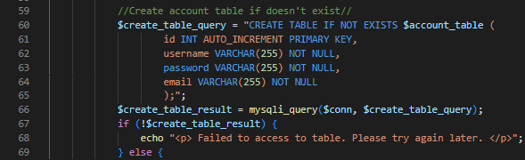

* Certain guidelines must be followed when entering the inputs:
* Email input must consist of characters, a "@" symbol, extra characters, a ".", and at least two letters (from a to z)
* The user's input for their username must be between 4 and 24 characters long and contain at least one lowercase character.
* The entered password must include at least one lowercase character and be between 4 and 18 characters.

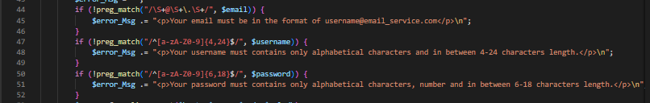

* Logout (logout.php): The only thing in this file is a php script that will close two variables of two users' data (username and email). 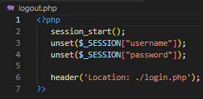
* Forms for signing up and logging in have a consistent background color with the other forms on the inquiry page. Additional designs, such as text boxes, submit buttons, and form layout, were influenced by some of the standard login and signup forms of well-known websites. 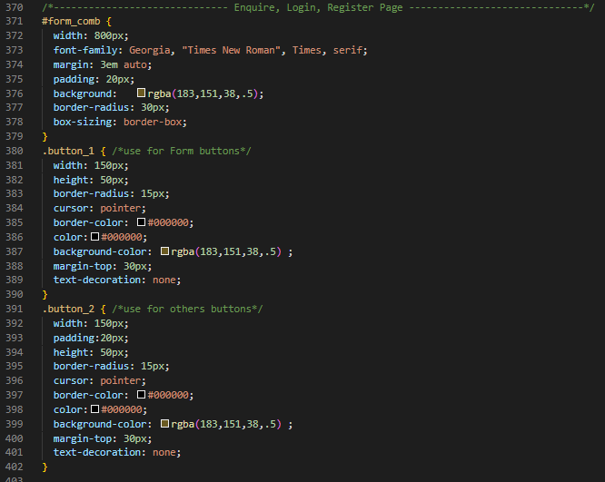
* Output

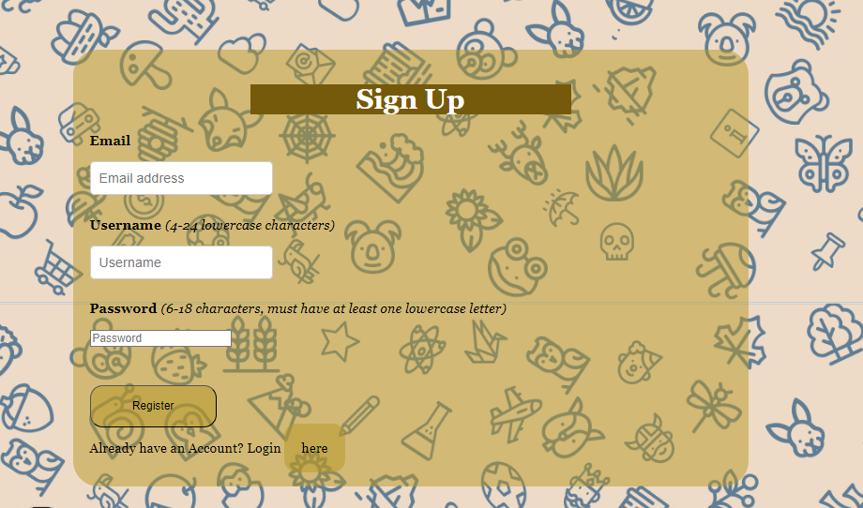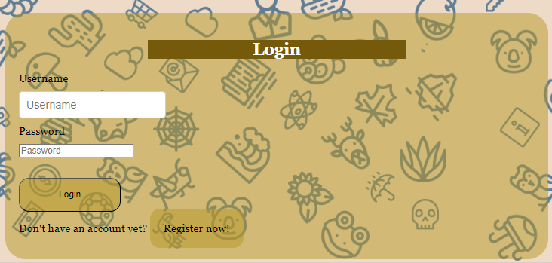

1. Reflection and Conclusion

I have a lot of experience working in groups now that Assignment Part 2 in particular and group projects in general are both complete. First, in my opinion, the best strategy to reduce workload is to assign each team member a portion of the project that best suits their skills and strengths. Second, The team as a whole, including myself, has to learn how to produce high-quality, readably structured code. It decreases the number of errors after completion since each team member is in responsibility of a specific portion of the project, and each of those portions is intricately related to the others. Last but not least, when working together, each member should consider the thoughts and contributions of the other members as well as their own role. This has improved our final website product significantly over the fragmented thoughts of the first design.

Conclusion on security:

We have made an effort to provide internet plans with the required amount of data at competitive prices in order to assess the viability of commercializing the products featured on our website. This, in my opinion, enables access to services for a wide range of clients. On the other hand, there are drawbacks to using our site. The issue of information security, particularly the server-side handling of the login-signup processes because it is too simple, is one of the main drawbacks, in my opinion. In the event that the website is made commercially viable and the services are made available, it is very likely that it will be the target of cyberattacks that steal user data. As a result, we realize that it is imperative that we develop our own skills and make an effort to make up for these weaknesses in our upcoming projects, including in upcoming Web applications units at Swinburne as well as in upcoming workplaces.

1. Conclusion

The characteristics and functionality of our website, including order processing, login, management page, and modifications required by the assignment, have all been proven in this report. The study also addressed the necessity of having a distinct professional goal, effective teamwork, and effective communication for database initiatives. Thank you for reading this report; if there are any queries about it, including regarding any mistakes or misconceptions, send an email to the following address: [104181789@student.swin.edu.au](mailto:104181789@student.swin.edu.au)

[dungnguyen15482@gmail.com](mailto:dungnguyen15482@gmail.com) (personal mail)